**LIST OF CONTENTS**

|  |  |  |
| --- | --- | --- |
| **CHAPTER**  **NO** | **CONTENT** | **PAGE NUMBER** |
| 1 | Introduction | 2-4 |
| 2 | Review of literature | 5-6 |
| 3 | Methodology | 7-8 |
| 4 | Waste management at neduvathoor panchayat | 9-12 |
| 5 | Finding, suggestions and conclusion | 13 |
| 6 | references | 14 |
| 7 | appendix | 15 |

CHAPTER 1

**INTRODUCTION**

**WASTE MANAGEMENT**

Waste includes items we don’t need and have therefore discarded. Waste comes in infinite sizes; it can be as small as a pin or as large as the body of a school bus. Essentially, waste refers to unwanted materials and objects that people have thrown away.

Waste management or waste disposal includes the processes and actions required to manage waste from its inception to its final disposal. Detection of chemicals of toxic nature in the water supply fruits and vegetables and in the water tables and their risk to health focussed the attention of public governments and the other organisations on the disposal of hazardous wastes and release of toxic substances in Environment. Waste management encompasses all types of waste, such as household, industrial and hazardous. Waste can also be solid, liquid or gas, each of which have their own methods of management and disposal. The earth’s ability to absorb our waste is a major factor inﬂuencing the adaptation of the waste treatment technologies. Landﬁlling is probably the oldest organized waste management technology. Direct impacts of waste represent a significant but comparatively small share of climate change, while resource depletion among similar effects is linked to indirect environmental impacts. This is mainly because indirect results of wastes are linked with the extraction and processing of different resources to produce different types of products while focusing on the output rather than the input in many industries.

**Why waste management is important**

Today, people are careless about what they do with their waste, and there are no proper methods to dispose of them. In this waste management essay, we will discuss the importance of waste management and look at different ways to manage waste.

Reuse of wastes has become very important not only in view of the fact that wastes pose a threat to environment but also due to the fact that waste disposal has become very expansive. Time now has come to formulate a national programme for waste reuse and recycling. According develop and strengthen national capacity to reuse the wastes in increasing proportions.

1. Provide incentives for waste reuse and recycling.
2. Change the existing norms to avoid discrimination against recycled material.
3. Develop public education and awareness programmes to promote the use of recycles products.
4. Local waste management organisations and municipal bodies should review all the available options and techniques making wate reuse an integral part of strategy for healthy living.
5. Identify potential markets for recycled products.

The environmental benefits of waste management are also many and varied. Reduce Waste in Landfills. Perhaps most importantly, it helps to reduce the amount of waste that is sent to landfill sites. Reduce Greenhouse Gases, Reduce Pollution, Reduce the Cost of Waste Disposal, More Job Opportunities, Boost Company Reputation.

Agenda 21 addressed the problem of waste management stating that sound management of waste is among the major environmental issues for maintaining the quality of earth’s environment and achieving sustainable development. Accordingly, waste management is to be done through following systems 1. minimum production of waste 2. maximising reuse of waste and recycling 3. promoting environmentally sound waste disposal practices 4. Extending waste services.

**LOCAL SELF GOVERNMENT**

Local self-government (LSG) is a system of governance where local bodies are elected by the people to manage the affairs of their local community. It's a democratic system that aims to empower local people to have a say in matters that impact their daily lives. Self-governing village communities have always existed in India since the earliest of times. Slowly over a period of time, these village bodies were converted to form Panchayats. Panchayats or Panchayati Raj is one of India’s oldest local self-government systems. The word ‘Panchayat’ means an assembly (Ayat) or five (panch) people who rule (raj). Elected local self-government bodies came into existence after 1882, when Lord Rippon, the father of local self-government, took the initiative to create these bodies. At that time, these were known as local boards. After the Government of India Act in 1919, village panchayats were firmly established in several provinces. While Rippon is widely known as the father of local self-government, Mahatma Gandhi is also a key player in decentralising political and economic power at the grassroots levels. Gandhi supported the strengthening of village panchayats and ensured the involvement of local self-governments in all developmental initiatives.

Local governments have a better understanding of the unique needs of their communities, allowing them to address issues like infrastructure, public services, education, and healthcare more effectively. By involving citizens in the governance process, LSG strengthens democratic values and empowers people to hold their elected representatives accountable. civil society helps ensure that panchayat policies reflect community needs, improving trust between the government and citizens. Panchayat surveys help in understanding local challenges such as poor sanitation, water shortages, unemployment, or waste management issues. Waste management is a growing concern in rural areas, and surveys help identify waste generation patterns, the effectiveness of existing waste management systems, and areas for improvement. Data from surveys can inform the planning of segregation, collection, and disposal strategies in alignment with community behaviour and preference

Civil Society denotes the sphere of action that lies between the state and society that is made up civic groups, civil society organizations, and non-governmental organizations. These all work to represent and promote certain special interests or raise public awareness of civic duties and political rights.

CHAPTER 2

**REVIEW OF LITERATURE**

1. **A review of waste management practices and their impact on human health**

**By L. Giusti august 2009**

This work reviews the most recent information on waste arisings and waste disposal options in the world, in the European Union (EU), in Organisation for Economic Co-operation and Development (OEDC) countries, and in some developing countries (notably China) and the potential direct and indirect impact of waste management activities on health. Though the main focus is primarily on Municipal solid waste (MSW), exposure bioaerosols from composting facilities and to pathogens from sewage treatment plants are considered. The reported effects of radioactive are also briefly reviewed. Hundreds Of epidemiological studies reported on the incidence of a wide range of possible illnesses on employees of waste facilities and on the resident population. The main conclusion of the overall assessment of the literature is that the evidence of adverse health outcomes for the general population living near landfill sites, incinerators, composting facilities and nuclear installations is usually insufficient and inconclusive. There is convincing evidence of a high risk of gastrointestinal problems associated with pathogens originating at sewage treatments plants. In order to improve the quality and usefulness of epidemiological studies applied to populations residing in areas where waste management facilities are located or planned, preference should be given to prospective of sufficient statistical power, with access to direct human exposure measurements, and supported by data on health effect biomarkers and susceptibility biomarkers.

**2.** **Environmental and health impacts of February 14, 2014 radiation release from the nation's only deep geologic nuclear waste repository**

The environmental impact of the February 14, 2014 [radiation](https://www.sciencedirect.com/topics/engineering/nuclear-reactor-accident) release  from the nation's only deep geologic waste repository, the Waste Isolation Pilot Plant (WIPP) was assessed using monitoring data from an independent monitoring program conducted by the Carlsbad Environmental Monitoring & Research Center (CEMRC). After almost 15 years of safe and efficient operations, the WIPP had one of its waste drums ruptures underground resulting in the release of moderate levels of radioactivity into the underground air. A small amount of radioactivity also escaped to the surface through the ventilation system and was detected above ground. It was the first unambiguous release from the WIPP repository. The dominant radionuclides released were americium and plutonium, in a ratio that matches the content of the breached drum. The accelerated air monitoring campaign, which began following the accident, indicates that releases were low and localized, and no radiation-related health effects among local workers or the public would be expected.

1. **Understanding the role of waste prevention in local waste management**

**By Kristina O Zacho**

Local waste management has so far been characterised by end-of-pipe solutions, landfilling, incineration, and recycling. End-of-pipe solutions build on a different mind-set than life cycle-based approaches, and for this reason**,** local waste managers are reluctant to consider strategies for waste prevention. To accelerate the transition of waste and resource management towards a more integrated management, waste prevention needs to play a larger role in the local waste management. In this review article, we collect knowledge from the scientific community on waste prevention of relevance to local waste management. We analyse the trends in the waste prevention literature by organising the literature into four categories. The results indicate an increasing interest in waste prevention, but not much literature specifically concerns the integration of prevention into the local waste management. However, evidence from the literature can inform local waste management on the prevention potential; the environmental and social effects of prevention; how individuals in households can be motivated to reduce waste; and how the effects of prevention measures can be monitored. Nevertheless, knowledge is still lacking on local waste prevention, especially regarding the methods for monitoring and how local waste management systems can be designed to encourage waste reduction in the households. We end the article with recommendations for future research. The literature review can be useful for both practitioners in the waste sector and for academics seeking an overview of previous research on waste prevention.

CHAPTER 3

**METHODOLOGY**

1. **STATEMENT OF PROBLEM**

In order to identify and study the various waste management strategies adopted by the panchayat, it's essential to analyse their methods, which typically include segregation at the source, composting of organic waste, recycling initiatives, and community awareness programs. Many panchayats implement door-to-door waste collection systems, often utilizing local volunteers to educate residents on proper waste disposal practices. By examining these strategies, we can gain insights into their effectiveness and the ways they foster community involvement in creating a cleaner environment.

1. **SIGNIFICANCE OF THE STUDY**

Waste management include the activities and actions required to manage waste from its inception to its final disposal. This includes the collection, segregation, transport, treatment and disposal of waste, together with monitoring and regulation of the waste management process. Waste management is a complex integration of resource management, economic development, public policy and acceptance, and government regulations while protecting the environment, promoting circular economy, and improving quality of life.

1. **OBJECTIVE OF THE STUDY**

The objective of the study is to analyse the waste management system of Neduvathoor panchayat puthoor.

1. **RESEARCH DESIGN**

The purpose of study is to analyse waste management practices and the research design is descriptive. Descriptive research aims to accurately and systematically describe a population, situation or phenomenon. It can answer what, where and how, but not why questions. A descriptive research design can use a wide variety of research method to investigate one or more variables. Unlike in experimental research, the researcher does not control or manipulate any of the variables, but only observes and measures them.

1. **UNIVERSE AND SAMPLE**

The universal study is the Local Self Government which includes Panchayath, Municipality and Corporation. The Sample size for my study is Panchayath. Naduvathoor Panchayat is the local self-government at the village level. It plays a crucial role in the administration of rural areas, addressing local issues, and implementing development projects. It is headed by a President Sussan George and has elected representatives called Panchayath Members.

1. **DATA COLLECTION**

The process of data collection was primarily. The data was collected through direct interview with the panchayat officials. The interview was recorded in audio format, and geotagged photos also were taken from the panchayat. The secondary data was acquired through the analysis of their past records and the other reports given by the panchayat.

**7 DATA ANALYSIS**

Through the qualitative analysis, the study shows the effectiveness of existing waste management initiatives. Interviews will be transcribed and reviewed. Taking notes, where an appropriate compromise as the participants were found to be reluctant and felt rather inhibited by the presence of recorders.

CHAPTER 4

**WASTE MANAGEMENT AT NEDUVATHOOR PUNCHAYATH**

Kerala State has 941 Grama Panchayats, 152 Block Panchayats, 14 District Panchayats, 87 Municipalities and 6 Corporations. Consequent to the 73rd and 74th amendments to the Constitution, the three-tier system came into existence in India. In Kerala, Local Self-Government Institutions have been meaningfully empowered through massive transfer of resources as well as administrative powers. Local self-government Institutions have emerged as effective agencies for the implementation of developmental programmes. Developmental programmes are identified and implemented through Grama Sabhas. With the decentralisation of power, Local administration department has gained an important role in the formulation and implementation of developmental works at the grass-root level. Today, Panchayat Directorate, Directorate of Urban Affairs, Commissionerate of Rural Development and Town and Country Planning Department are the major allied departments of Local Administration. Related to local administration activities, there are different allied institutions and training canters under LSGD.

Neduvathoor Panchayat deals with different kinds of waste management strategies mainly they focus on the Haritha karma scena in collaboration with kudumbashree. The Gram Panchayat shall be responsible for Door-to-Door Collection of segregated Solid Waste at such times and in such manner as shall be notified by the Gram Panchayat in accordance with these Bye-laws. Haritha Karma Sena generates revenue for local bodies, as households pay Rs.50 and businesses Rs.100 for plastic waste collection each month. they collect plastics (which include milk packages, plastic covers and other plastic materials) from the households and they separate the plastics and recycle it. The collected plastics are stored in the mini material collection facilities. The panchayat has two MCFs which is situated in the kotatala. They also have door to door service they succeed 100% in the collection of plastics and they provide a user fee for that. There are some peoples who don’t give that and for that the panchayat members will come and talk to the respective peoples and also provide awareness regarding the same. The workers in the Haritha karma scena will get a minimum amount of RS 10000 as income. Every two month the Haritha scena workers are allocated in each ward to collect the waste. The panchayat also come with penalties and fines for disposing wastes in public places. If someone saw a person throwing waste and have a video recording the person has to pay a fine of Rs 2500. they also have digitization in the panchayat they provide a QR code which is placed in every house. There is App for that which is Haritha Mithram. They monitor the activities through the Haritha Mithram web portal. The panchayat also conducts many awareness programs.

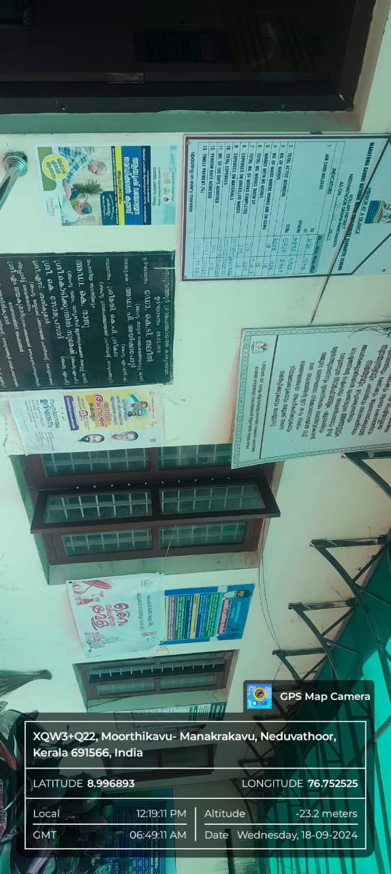

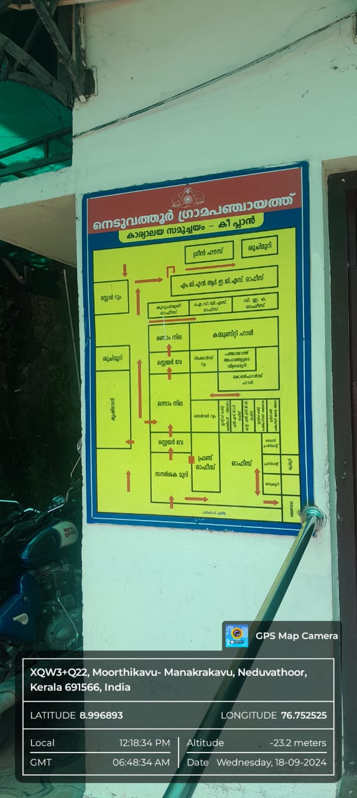

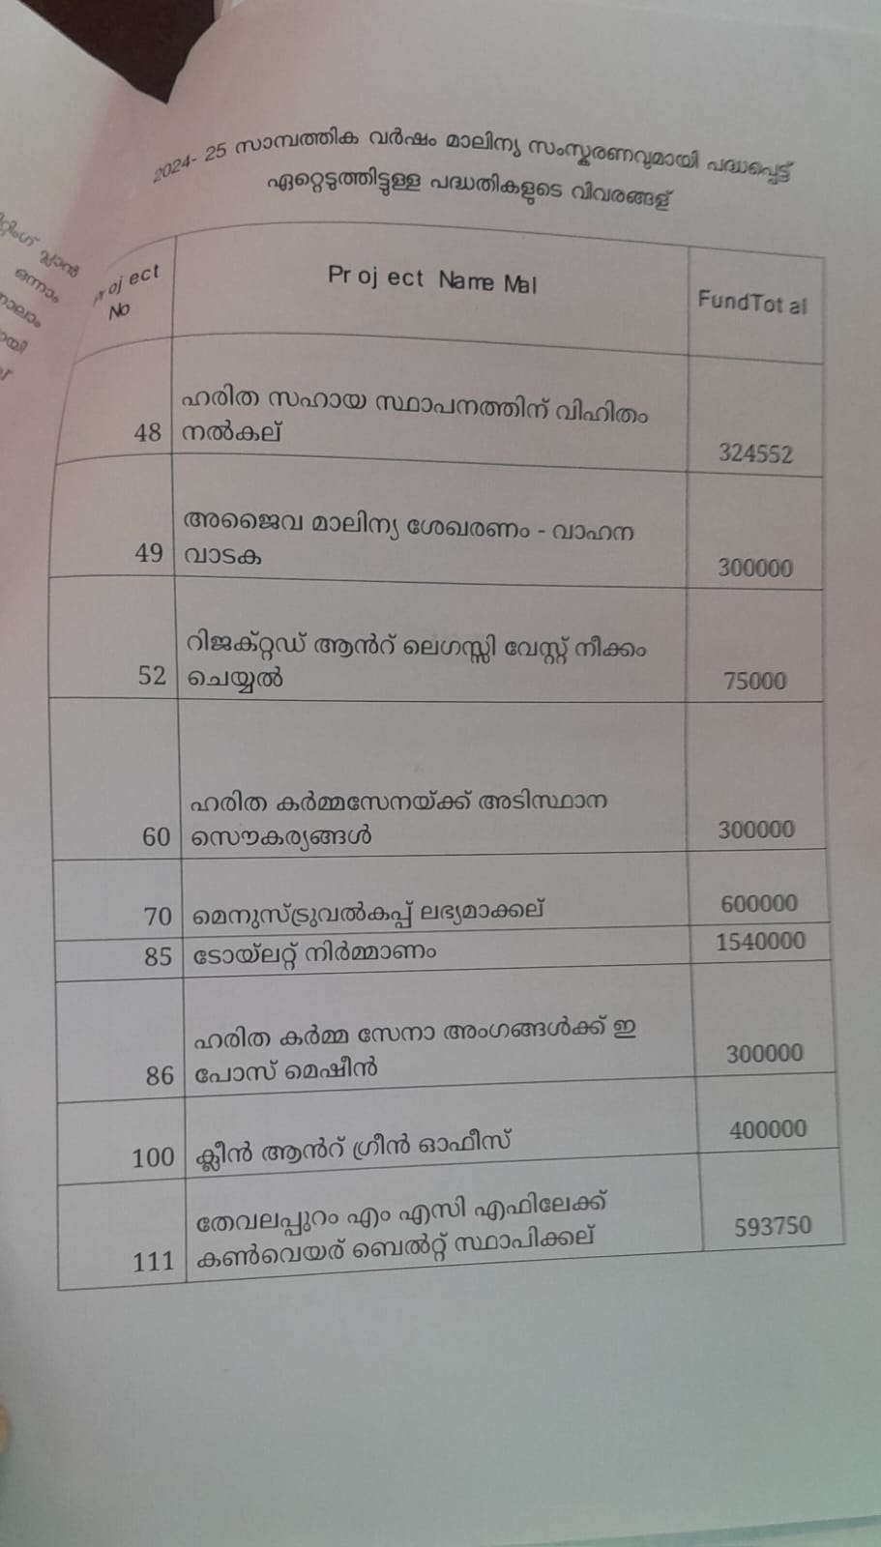

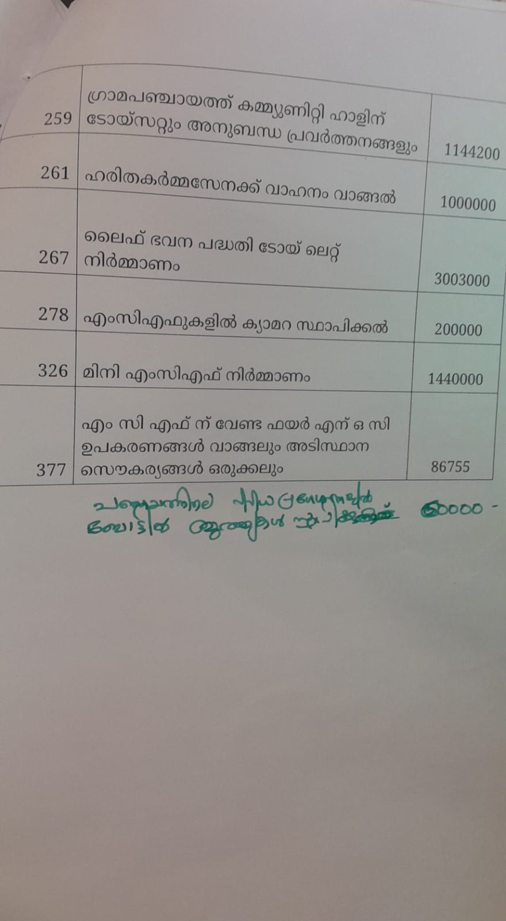

CHAPTER 5

**FINDINGS, SUGGESTIONS, AND CONCLUSION**

The waste management study at the neduvathoor panchayat reveals several key findings about how the waste is allocates and manage in panchayat and the wards. It provides livelihood to its members.

The collected waste is stored in local Material Collection Facilities (MCFs) and later transferred to the main MCF in Kollam, from where it is handed over to Clean Kerala Company, a government agency. Catering units and hotels are required to follow the waste management practices, where solid degradable waste should store in bio-bins and liquid waste should properly treated and stored in tanks. Through diverse and innovative projects, activities and campaigns, Haritha Kerala Mission has been able to bring about positive changes in the sanitation and waste management sector in the state. Activities like the Green Law awareness campaign became a powerful public education programme. Along with the material gains made in all these fields, the value-based achievements made on the intellectual level are also remarkable.

They also have awareness campaign regarding waste management and the strategies.

The main challenges faced by the panchayath is that lack of cooperation from the people. Some of the households are refusing to pay the fee. They can conduct more awareness programmes regarding this. There is no CCTV in the surroundings of the panchayath only few places are under the surveillance of the CCTV so they can place more cameras. Government initiatives like Swachh Bharat Abhiyan (Clean India Mission) and Suchitwa Mission have further encouraged to improve waste management at the Panchayat level. Recycle what you can, and make sure to segregate your waste into different bins. The panchayat also can use color-coded bins for different types of waste, such as organic, glass, paper, metal, plastic, and hazardous waste.

In conclusion we can say that Waste management is a critical aspect of environmental sustainability and public health. As urbanization and population growth continue to rise, the effective management of waste has become increasingly essential. Proper waste management not only minimizes the impact of waste on the environment but also conserves natural resources, reduces pollution, and fosters a healthier community. Adopting integrated waste management strategies—such as waste reduction, recycling, composting, and responsible disposal—can significantly mitigate the adverse effects of waste. Public awareness and community participation are crucial in implementing these strategies successfully. Education on the importance of waste segregation and responsible disposal practices can empower individuals to take active roles in waste management efforts.

**REFERENCES**

1. Zacho, K. O., & Mosgaard, M. A. (2016). *Waste Management & Research*
2. Giusti, L. (2009). *A review of waste management practices and their impact on human health*. *Waste Management*
3. Thakur, P., Lemons, B. G., Ballard, S., & Hardy, R. (2015). Environmental and health impacts of February 14, 2014, radiation release from the nation's only deep geologic nuclear waste repository. *Journal of Environmental Management*
4. <https://scholar.google.com/>
5. Environmental management text book by N K Uberoi
6. *Waste management*. BYJU'S.

[https://byjus.com/kids-learning/waste-management-essay/](https://byjus.com/kids-learning/waste-management-essay/ )

1. Unacademy
2. https://unacademy.com/content/neet-ug/study-material/chemistry/waste-management/<https://unacademy.com/content/neet-ug/study-material/chemistry/waste-management/>

**APPENDIX**

1. What are the waste management strategies adopted by the panchayat?
2. Do you believe that individuals can make a difference in waste management?
3. How well is waste management going?
4. How are the waste collected?
5. What types of waste do you think are most problematic and how are they managed?
6. What is the biggest challenge in waste management?
7. How often the panchayat initiates in community clean-up events or recycling drives?
8. What are the future plans and goals for waste management?